**Challenge 4**

[www.pythonchallenge.com/pc/def/linkedlist.php](http://www.pythonchallenge.com/pc/def/linkedlist.phpl)

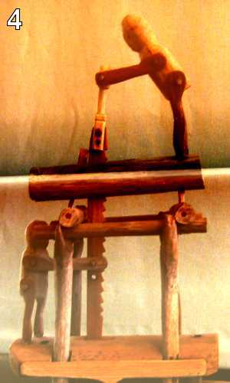

The page title is ‘Follow the chain’ which makes sense with linked list. The only thing in the page source is this:

|  |
| --- |
| <!-- urllib may help. DON'T TRY ALL NOTHINGS, since it will never |
|  | end. 400 times is more than enough. --> |
| I was stumped with this. Researched what a .php file is:  PHP file is**a webpage that contains PHP (Hypertext Preprocessor) code.**  A file with the .php file extension is**a plain-text file that contains the source code written in the PHP (it’s a recursive acronym meaning PHP: Hypertext Preprocessor) programming language.**  Huh? I fretted over this one and finally went to look at other people’s solutions. The trick is to click on the picture. That takes you to [www.pythonchallenge.com/pc/def/linkedlist.php?nothing=12345](http://www.pythonchallenge.com/pc/def/linkedlist.php?nothing=12345) which has the message and the next nothing is 44827.  Notice the **?nothing=12345**. So, the start of the chain is 12345 and the next is 44827. Putting 44827 in for 12345 and get another one with a different next nothing. So pychallenge4.py is a loop through the webpages until error. This takes a while and finally gives and end-of-chain message: Yes. Divide by two and keep going. 16044 is the last in the chain. Next tried 8022 as the start of the chain and did the loop again.  Aargh! Got this message:  End of the chain message: 82683 You've been misleaded to here. Go to previous one and check.  Added a list to save the nothings and reran to get next to last number in the chain: There maybe misleading numbers in the text. One example is 82683. Look only for the next nothing and the next nothing is 63579  This means that the **re** pattern should have looked for ‘next nothing is and what comes after that instead of just numbers. Rerunning finally get ‘peak.html’. This url leads to next challenge.  The page title is ‘Follow the chain’ which makes sense with linked list. |  |